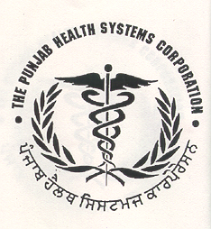
PUNJAB HEALTH SYSTEMS CORPORATION
E-Block, 2nd Floor, Phase-8, (Sector 62)
Punjab School Education Board Complex
Sahibzada Ajit Singh Nagar (Mohali), PUNJAB
Phone: 0172- 2232245 & 2232247
Visit us at: phsc.punjab.gov.in:
E-mail: proc.directorphsc@gmail.com , procmedicinephsc@gmail.com

Bid Ref No. PHSC/Proc/2022/AAC

ADDENDUM

A notice inviting quotations was published in the newspapers for procurement of medicines. One more item has been added in the schedule of requirements and revised scheduled of requirements is as under :

Sr. No. | Name of the Medicine | Qty | EMD ( In Rs) | Delivery period
1 | Tab Nifedipine10mg | 15000 tablets | 1000.00 | Immediately within 4 days
2 | Syrup Phenytion Sodium 125mg/5ml, 100 ml bottle | 3600 bottles | 4000.00
3 | Tab.Ornidazole 500 mg | 220000 tablets | 4000.00

Corrigendum/Addendum if any will only be published on website : www. phsc.punjab.gov.in.

